Notice Posted: May 23, 2022 @ 5:00 pm
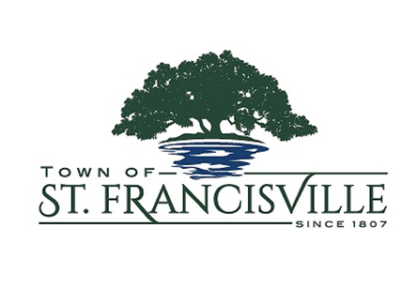
NOTICE OF PUBLIC MEETING

A Public Meeting will be held as follows:

DATE: MAY 24, 2022
TIME: 5:30 P.M.
PLACE OF MEETING: DUE TO BOARD ROOM RENOVATIONS
THE MEETING LOCATION WILL BE MOVED TO:
OLD MARKET HALL
9896 ROYAL STREET
ST FRANCISVILLE, LA 70775
AGENDA

Call to Order

Roll Call

Prayer

Pledge

Approval of the Minutes from the May 10, 2022 Regular Meeting.

Reading of the Public Comment in Meetings Policy

PUBLIC MEETING

Open Public Meeting

Call for Public Comments on Agenda Items

PEC Report – Bianca Hillhouse

BUSINESS ITEMS:

- Introduce Ordinance 2022-6
An ORDINANCE Amending an Operating Budget of Revenues and Expenditures for the Fiscal Year Beginning July 1, 2021 and Ending June 30, 2022 and Adopting an Operating Budget of Revenues and Expenditures for the Fiscal Year Beginning July 1, 2022 and Ending June 30, 2023

- Introduce Ordinance 2022-7 – An Ordinance of the Board of Aldermen of the Town of St. Francisville; to Amend and Extend the Moratorium on the Issuance of Any Permits by the Town of St. Francisville for the Improvement or Development of (A) Any Lots Which are Part of a Major Subdivison and/or Resubdivision of Land, and (B) New Multi-Unt Residentual Structures Incorporating more Than four (4) individual units total, per site.

Departmental Updates – Mayor Leake

Mayor’s Comments

Attorney Update

Police Report

Permitting & Planning Updates

Main Street Report

Council Concerns

Adjournment

Robert P. Leake, Mayor
Town of St. Francisville
P.O Box 400 – 11936 Ferdinand Street St. Francisville, La 70775.
Phone (225) 635-3688

THE MEETING IS OPEN TO THE PUBLIC.

PUBLIC COMMENT IN MEETINGS POLICY STATEMENT. An opportunity for public comment shall be observed before a vote is taken on any agenda item. Once recognized by the presiding officer, the person afforded the floor, shall identify the agenda item upon which he or she wishes to provide comment and shall limit his or her comments to matters that are strictly relevant to that agenda item. Commentary shall not exceed three (3) minute per person. No dialogue between Board members or the Mayor (or Mayor Pro Tem) and the public shall be permitted at these meetings, except to clarify the nature of questions and/or comments. The presiding officer reserves the right to limit and/or terminate any commentary when deemed necessary or outside of public decorum.

This Institution is an Equal Opportunity Provider.

Town of St. Francisville
P.O. Box 400 * St. Francisville, LA 70775
* Phone (225) 635-3688 * Fax (225) 635-6984 * email: townhall@townofstf.com

